1. **Setting up environment,**

$ conda create -n learn_dbt -y

$ pip install dbt-<adapter_name>

1. **Installing dbt client/database**

$ pip install dbt-duckdb

1. **Initializing Project**

**$ dbt init dbt_learn**

1. **Locating Project Folder**

**$ cd dbt_learn**

**Purpose of dbt Project Profiles**

We have initialized a dbt project and now, we need to connect to an existing database (or create one from scratch).

In linux:- ~/.dbt/profiles.yml

C:\Users\<YourUsername>\.dbt\profiles.yml

To do this, we need a secure way to feed database credentials to dbt to establish a connection. This is where we will use a **project profile**.

It can be inside project folder too,

Like this: dbt_learn/

├── models/

├── seeds/

├── snapshots/

├── tests/

├── macros/

├── analyses/

├── dbt_project.yml

├── profiles.yml # Note: This is usually located in ~/.dbt or equivalent

└── README.md

dbt_project.yml and profiles.yml

**5.Structure Of dbt_project.yml and profiles.yml file**

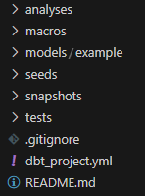

**dbt_project.yml**

**name: 'dbt_learn'**

**version: '1.0'**

**profile: 'dbt_learn' # This should match the profile name in profiles.yml**

**profiles.yml**

**dbt_learn:**

**target: dev**

**outputs:**

**dev:**

**type: bigquery**

**project: my_project_id**

**dataset: my_dataset**

**threads: 4**

**keyfile: /path/to/keyfile.json**

**prod:**

**type: bigquery**

**project: my_project_id**

**dataset: my_dataset**

**threads: 4**

**keyfile: /path/to/keyfile.json**

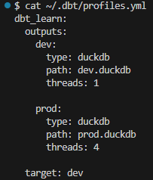

1. **Creating database using dbt debug command**

$ dbt debug

Dbt debug command look into profiles.yml settings and make forward changes to project folder according to profiles.yml if needed

Since we don't have a database called dev.duckdb, we will let dbt create it by running dbt debug.

**7. Creating DBT Models**

To Be Continued……